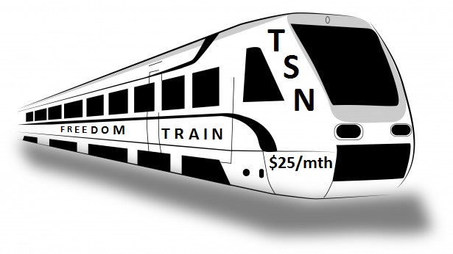
58 Million People Earn Less Than $15/hr
  - Thanks to a $25 monthly referral opportunity, everyone could do better. Touchstone Success Network’s Life Lessons Personal Development Referral System is helping people from the bottom up. Would your life get better with a little personal development and a good way to earn a little extra income?

Yes, we’re living in challenging times, but we’re not powerless to improve our lives. In 2012, a group of veteran networkers wanted to help more people earn extra income through referral marketing. They decided that affordability and recruiting by mail with a simple flyer would make it easy to get started right away. If you’re open to listening to success audios and referring others, we can help you earn a little extra income. Everyone getting just 3 others to join us would make $1,089 a month possible. I hate seeing people working extra jobs trying to earn an extra $300 to $1,000 a month. Please know this is not a hobby, not something for nothing, and definitely not a get-rich-quick scheme. It’s a business promoting personal and financial growth. It’s about empowering average working people. We’re teaching life lessons that can lead to growth, success and financial security. As a subscriber, you’ll receive our monthly audio messages. The cost is $25 monthly. A one-time $10 account setup fee gets you assigned a partner ID and a replicated website. You’ll earn a $15 Fast Start Commission on your personal referral’s 1st purchase and a $3 monthly commission on monthly recurring purchases. Every partner referring just 3 others would pay you $1,089 per month. Company support is great. Our system works both on-line and by direct mail. Listen to 5-minute recording @ 518-777-5095 and/or my weekly recorded conference call @ 641-715-3900 pin 696016#. Learn more @ our info website www.touchstonesuccess.info Call, text or email me your toughest questions. Yours to Count On, Danny Pollard, Founder 804.761.8253 or dannycpollard@yahoo.com.
Enroll online @ www.touchstonesuccess.com or by returning the coupon below. Send $35 today (Check, Money Order or Cash), then send just $25 every month to: Touchstone Success Network, 992 Eastern View Rd, Saint Stephens Church VA 23148 Hope you’ll join our team!
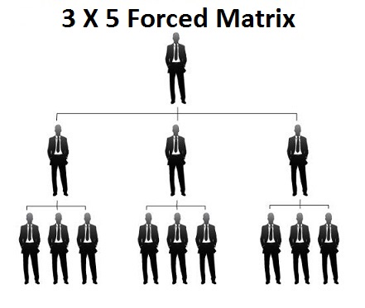
----------------------------------------------------------------------Mail-in Application------------------------------------------------------------------------------
Referred by Touchstone Success Partner: ID: $35 gets you enrolled today!
Your Name: ________________________________________________
Address: ___________________________________________________
___________________________________________________________
Phone:
Email:

