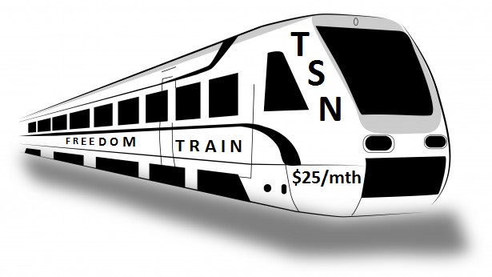
Thanks to A $25 Referral Opportunity
  - Everyone could be earning passive residual income!
Our mission is to organize, educate and empower average people with a path to more successful and prosperous lives through personal development and referral marketing. It’s amazing what we can accomplish with $25/mth.

Touchstone Success Network (TSN) was founded in 2012 by veteran direct mail networkers who wanted to help more people earn extra income. We realized most would need continuous personal and mindset development training and support. We also believed affordability and recruiting by mail with a simple flyer like this would help more people start passing the word right away. Subscribing to TSN is like subscribing to a monthly magazine. You’ll receive our monthly audio CD messages and earned commissions by mail. The keys to our success are continuous personal growth, persistent sharing, unity, patience and trusting the process. We’ll pay you a $15 Fast Start Bonus Commission the first month on each new subscriber/customer you recruit. We also pay you a $3 residual commission on each subscriber’s recurring monthly audio CD purchases. Plus, we’ll pay you a $3 residual commission on subscribers recruited by others on your team down through 5 pay levels. The income potential is good with everyone referring 3 to 5 subscribers. Our pay plan is a forced matrix starting 3-wide, expandable to unlimited width. Company support is great. Listen to 5-minute recording @ 518-777-5095 and/or my weekly recorded conference call @ 641-715-3900 pin 696016#. Learn more @ www.touchstonesuccess.info Call, text or email me with your toughest questions.
Danny Pollard @ 804.761.8253 or dannycpollard@yahoo.com. Today’s Best $25 Referral Opportunity
To get enrolled by mail, send $35 today (Check, Money Order or Cash), then send just $25 every month to:
Touchstone Success Network, 992 Eastern View Rd, Saint Stephens Church VA 23148
Enroll online @ www.touchstonesuccess.com/ Hope you’ll join us!
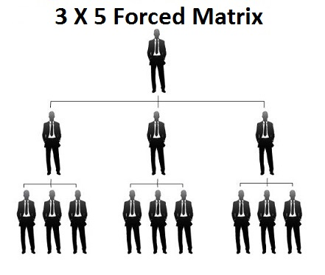
----------------------------------------------------------------------Mail-in Application------------------------------------------------------------------------------Your Name:
Address:

Phone:
Email:

Referred by: ID:

